TASK-1
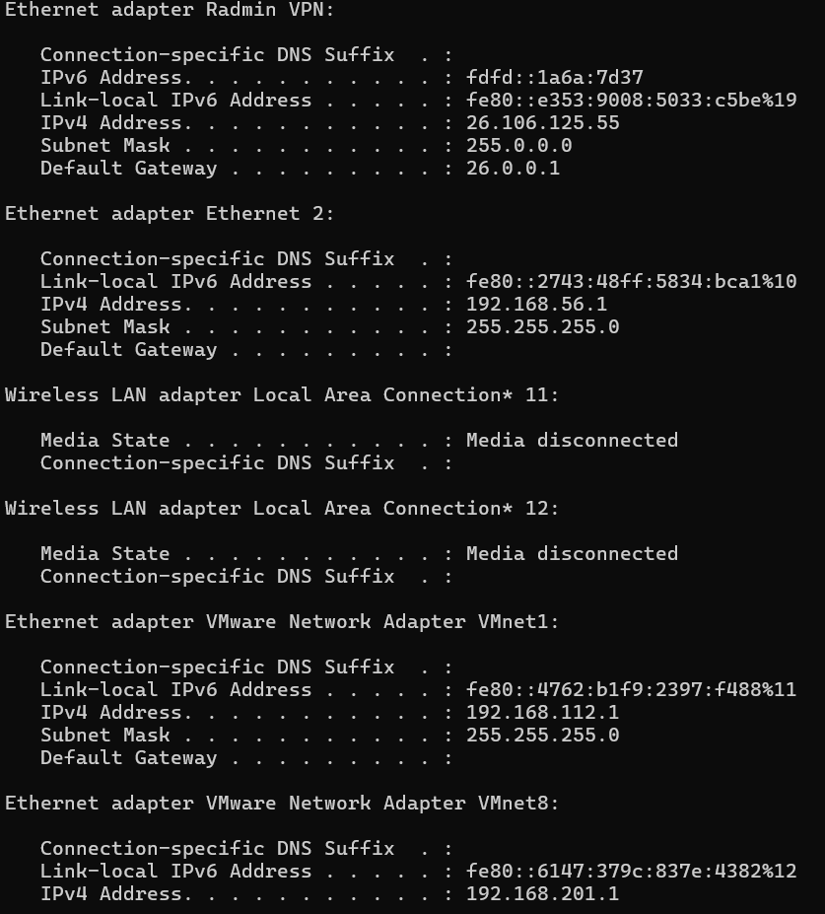
TASK-2
IPv4 Address. . . . . . . . . . . : 10.141.197.246
Subnet Mask . . . . . . . . . . . : 255.255.255.0
Default Gateway . . . . . . . . . : 10.141.197.190
TASK-3
Here is what happens in this scenario when you perform these actions:
1. When You Change to a Static IP (192.168.1.50)
- Immediate Network Connection: Since 192.168.1.50 is in the same IP range as your router (192.168.1.x) and uses the same Subnet Mask (255.255.255.0), your device stays connected to the local network without any interruption.
- Internet Access Status: You will still have internet access, provided that:
  - The IP address 192.168.1.50 isn't already being used by another device on your network (to avoid an IP conflict).
  - You correctly set the Default Gateway (your router’s IP, 192.168.1.1) and a DNS Server (like 8.8.8.8 or your router's IP).
- Behind the Scenes: Your router stops assigning an IP to your device dynamically via DHCP. Instead, your computer manually tells the router, "I am using 192.168.1.50 from now on."
2. Why You Must Revert Back to DHCP (Automatic IP)
- IP Conflicts Later: If you leave it as a static IP and connect to another Wi-Fi network (like at a cafe, office, or friend's house) that uses a different IP range (e.g., 10.0.0.x), your device will completely lose internet access.
- Seamless Connectivity: Reverting back to DHCP allows your device to automatically request and receive a valid, conflict-free IP address wherever you connect.

TASK-4
Typical DHCP Range Location & Example
In most router admin panels (usually found under LAN Setup, Network Settings, or DHCP Server), you will see a starting and ending IP address.
- Current Typical Range: 192.168.1.100 to 192.168.1.199
What Happens if Two Devices Get the Same IP?
If two devices are assigned the exact same IP address, an IP conflict occurs, confusing the router about which specific device should receive the incoming data packets. As a result, one or both devices will experience erratic network behavior, dropped connections, or a complete loss of internet access until the conflict is resolved.

